# Important java script array methods (higher order function)

* For Each

      for (let i = 0; i < ages.length; i++) {

        console.log(ages[i]);

      }

      cars.forEach(function (*car*) {

        console.log(*car*);

      });

      cars.forEach(c*ar*=>console.log(*car*));

* Filter

 const younger = [];

      for (let i = 0; i < ages.length; i++) {

        if (ages[i] < 20) {

          younger.push(ages[i]);

        }

      }

      console.log(younger);

      console.log(ages.filter((*age*) => *age* < 30));

      const company = [

        { id: '1', name: 'sajeewa', grade: 4 },

        { id: '2', name: 'samadhi', grade: 5 },

        { id: '3', name: 'geethan', grade: 3 },

        { id: '4', name: 'geethan', grade: 9 },

        { id: '5', name: 'geethan', grade: 7 },

      ];

      const Grade4student = company.filter(function (*company_pass*) {

        if (*company_pass*.grade == 4) {

          return true;

        }

      });

      const Grade4student1 = company.filter(

        (*company_pass*) => *company_pass*.grade > 4 && *company_pass*.grade < 7

      );

* Map

 const studentNames = company.map((*student*) => *student*.name);

      console.log(studentNames); //[ "sajeewa", "samadhi", "geethan", "geethan", "geethan" ]

* Sort

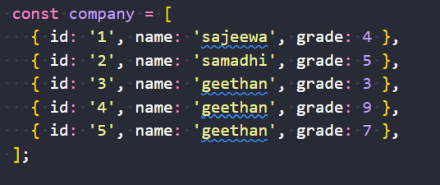

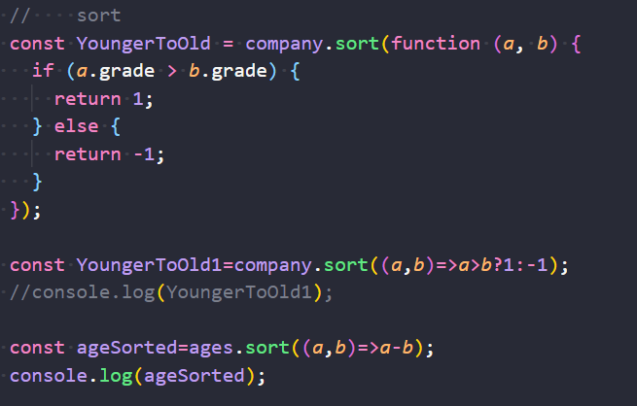

* Reduce

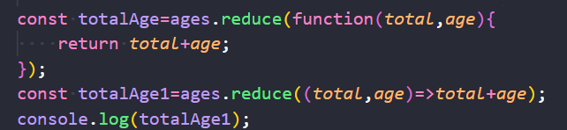

* All together
* const combined=ages.map(*age*=>*age*\*2).filter(*age*=>*age*>40).sort((*a*,*b*)=>*a*-*b*).reduce((*a*,*b*)=>*a*+*b*,0);
* console.log(combined);